THE SOUTH DARWIN CU-AU-FE-REE DISCOVERY IN THE MOUNT READ VOLCANICS, WEST COAST TASMANIA

Charles E. D. Hughes
Corona Minerals Ltd, 703 Murray Street, West Perth, WA 6005
Key words copper, gold, magnetite, rare earth elements, magmatic hydrothermal breccia, Mount Read Volcanics

Abstract
The South Darwin Cu-Au-Fe-REE discovery is situated 20km south of the historic mining centre of Queenstown on the West Coast of Tasmania, hosted within the late Cambrian aged Mount Read Volcanics (MRV). South Darwin is unusual for the MRV; with its mineralisation style (polyphase hydrothermal magmatic breccia), alteration assemblage (strongly potassic, with iron oxide, tourmaline, apatite, allanite and fluorite) and associated metals (Cu-Au-Fe-Ag-REE-W-Mo) similar to that seen at Ernest Henry in the Cloncurry district (insert reference). Regional scale potassic alteration is present over 15km of strike, with intense alteration present over 5km of strike in the vicinity of South Darwin. Mineralisation is controlled by a major NNE trending fault that appears to have controlled the emplacement of a suite of late Cambrian granitoids (the “Darwin Granite”) that sit adjacent to the South Darwin mineralisation.

Geological Setting
South Darwin is located towards the southern end of the MRV and is located on one of the only sheets within the MRV that hasn’t been subject to 1:25,000 mapping by Government Geologists. Regional scale mapping (Figure 1) indicates South Darwin mineralisation is present close to the boundary between the Central Volcanic Complex (CVC) and Western Volcanosedimentary Sequence (WVS).
Interpretation of detailed 1:5000 scale mapping at South Darwin (Figure 3) mineralisation is hosted by a polyphase magmatic hydrothermal breccia, controlled by a major NNE striking regional fault (Darwin Fault), and minor ENE striking faults. The hydrothermal magmatic breccia appears to dip steeply to the east, reflecting the orientation of the Darwin Fault, and sits between an intensely altered dacite to the east, and a less altered rhyolitic unit to the west. Both dacite and rhyolite units appear to dip moderately to the west. The dacite unit (in which the breccia is favourably developed) is extensively altered and is predominantly a coherent volcanic, with suite 1 affinities (Crawford et al 1992), typical of the CVC .The rhyolitic unit to the west is mostly coherent, generally quartz phyric, but does have some well-developed pepperitic textures in places. This rhyolite is tentatively ascribed to the WVS. The Darwin Granite that sits adjacent to the mineralisation is a suite of highly fractionated and differentiated I-type magnetite series granitoids that vary from granite (sensu stricto) to granodiorite (Wyman, 2001).

Mineralisation
Current knowledge indicates copper mineralisation is intimately associated with the development of iron oxide rich hydrothermal breccias. However there is scope for significant other mineralisation style to be present. Mineralisation appears to form pipe like bodies that have developed along the Darwin fault in association with cross cutting structures, and possibly more chemically reactive stratigraphy.

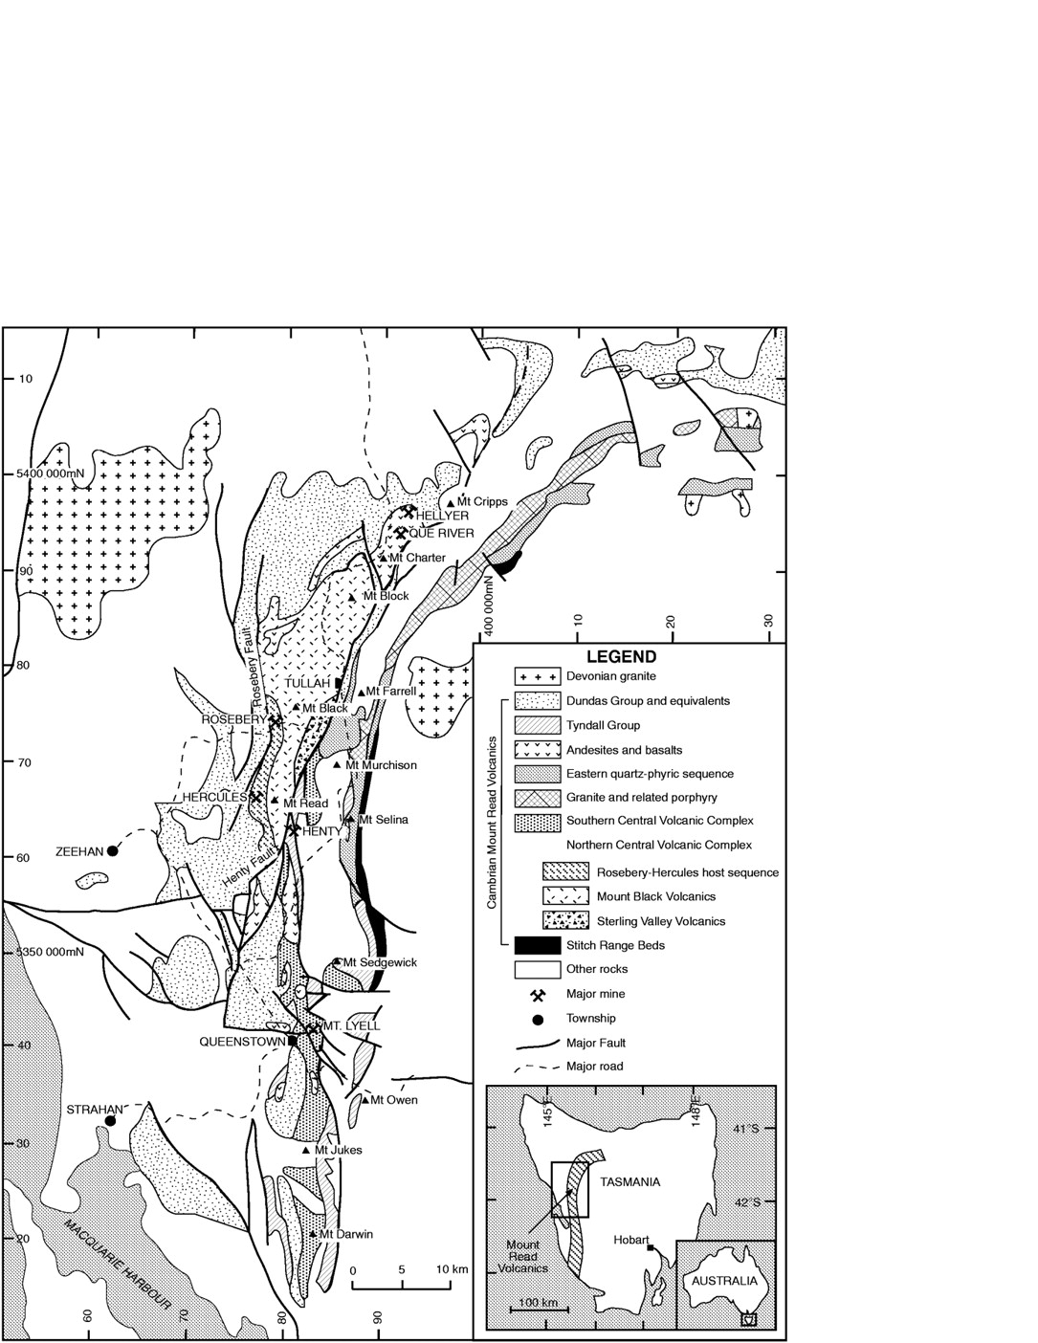
Figure 1 Location of South Darwin (after Corbett, 1992)
South Darwin

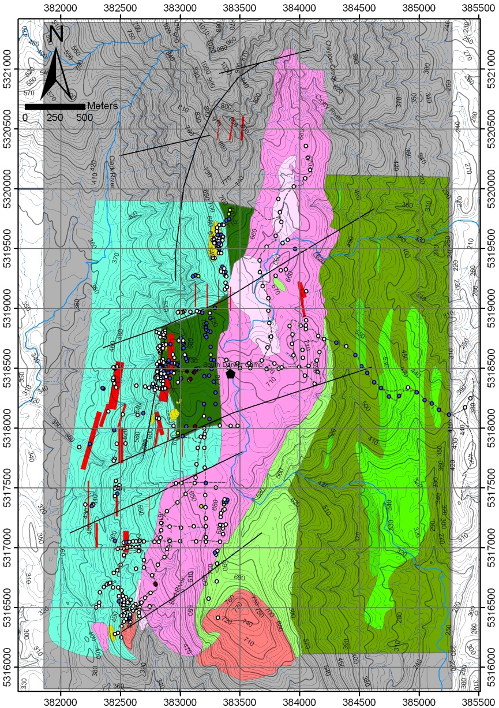
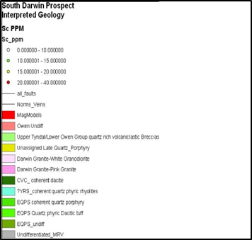
Prince Darwin breccia
Darwin Fault

Figure 2 Local geological interpretation of the South Darwin area

Copper mineralisation is observed as three phases:
- Chalcopyrite associated with Fe-oxide rich magmatic hydrothermal breccias as disseminations and breccia matrix fill. This phase of copper mineralisation is associated with intensely alkaline and pottassic alteration, and a host of other alteration minerals that are described later. Copper gold ratios are uniformly 3:1 (as per Mt Lyell) in this alteration phase. REE as allanite, monazite, & REE-carbonates; W as scheelite and Mo (as yet unidentified mineral) appear to be associated with this main phase of mineralisation.

- Chalcopyrite associated with more muscovitic white mica and Fe-rich chlorite alteration within the coherent dacite unit, as stockworks and disseminations. This phase of copper mineralisation is not associated with magnetite and as such has not yet been targeted specifically. Copper gold ratios are higher in this phase of mineralisation being ~ 5:1, and anomalous levels of Sb are associated with the mineralisation.

- Minor stratabound chalcopyrite associated with k-feldspar and chlorite development in the WVS. Copper gold ratios are 10:1.
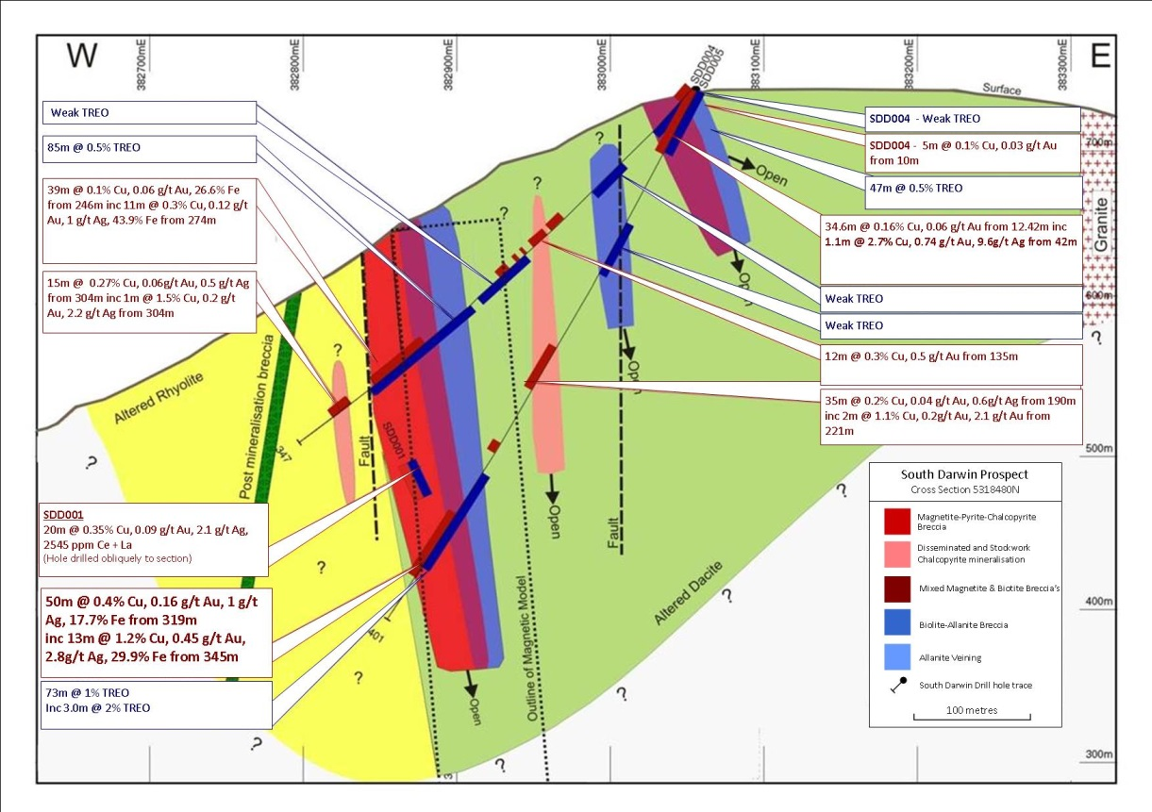

Figure 3 cross section of drilling at South Darwin

Alteration
Alteration is dominated by iron oxide phases, predominantly magnetite, although hematite breccias are recognised and may represent a higher level expression of the mineralising system. A complex assemblage of alteration minerals is associated with mineralisation and summarised and tabulated below.

Alteration phase | Timing
 | Pre mineral | Early syn-mineral | Late mineral | Post mineral
Albite
Biotite
Magnetite
Hematite
Phengite
Muscovite
Chlorite
k-feldspar
Quartz
Pyrite
Calcite
Siderite
Chalcopyrite
Tourmaline
Apatite
Barite
Allanite
REE carbonates
monazite
Fluorite

Table 1. Alteration minerals and rough timing relationships

Brief exploration history
The South Darwin area has been subject to prospecting and exploration efforts dating back to 1896 when, on the back of successes at Mt Lyell, several parties staked claims and sunk and drove exploration shafts and adits on “ironstone”, in the hope that similar luck would be met with as that seen at the “iron blow”, the original Mt Lyell discovery. Copper was discovered in several locations chief of which was Prince Darwin, where the Prince Darwin coper company was formed and subsequently disbanded 1 year later on the back of the local copper smelter shutting down. Economic woes and World Wars appear to have upheld exploration efforts in the South Darwin area as the locality wasn’t again visited until 1957, when the Mt Lyell Mining and Railway Company sent an expeditionary team to assess the area after a major bush fire where mapping trenching and sampling indicated widths of about 70m and lengths of at least 200m for an assumed steeply west dipping magnetite breccia. Channel sampling of the Prince Darwin adit returned 60m @ 0.5% Cu by BHP in 1964 who drilled a hole 800m south of the Prince Darwin adit and erroneously marked the drill hole collar on a map as being adjacent to Prince Darwin. Only minor work was undertaken from this point on by a handful of companies until Jaguar Minerals Ltd acquired EL51/2008 in late 2008, after Newcrest Ltd relinquished the project. Jaguar completed minor work on the South Darwin area and was mostly focussed on other prospects, and eventually farmed out the project to Corona Minerals Ltd (Corona) in 2010.
Corona undertook a project wide VTEM and aeromagnetic survey and thorough historical research, and quickly prioritised the South Darwin area for several reasons:
- South Darwin was located within a zone of extensive regional alteration, where kspar-magnetite alteration is developed and effect magnetics for at least 16km of strike
- South Darwin is adjacent to a major structure that has controlled or facilitated the emplacement of a granite
- An extensive modelled magnetic anomaly near the Prince Darwin adit was present with dimensions of 70m wide x300m long x >1000m deep, with an SI of 1 (indicating 30% magnetite)
- Historical records indicated the magnetic body was associated with copper mineralisation and had not been drilled by BHP, contrary to the belief of Exploration Company’s post 1970.

Drillhole SDD001 was helicopter supported and collared near the Prince Darwin adit, on the precipitous western slopes of the Darwin Plateau and drilled to the South east. SDD001 returned 124m @ 0.4% Cu, 0.14 g/t Au. The entirety of the 376m hole was altered, with mineralisation present from surface over 225m @ 0.26% Cu. A further four diamond drill holes have been drilled with best result from SDD005: 50m @ 0.4 % Cu, 0.15 g/t Au from, inc 13m @ 1.2% Cu, 0.5 g/t Au & 30m @ 2% TREO. A lack of available funds has affected the development of this prospect.

Acknowledgements
The author would like to thank Mr Terry Middleton for years of invaluable technical advice, guidance and mentorship, without which Corona would not have made this discovery.

References
Corbett, K.D. 1992. Stratigraphic-volcanic setting of massive sulphide deposits in the ambrian Mount Read Volcanics, Tasmania. Economic Geology v. 87, p. 564-586.
Wyman, W.F. 2001. Cambrian Granite-Related Hydrothermal Alteration and Cu-Au Mineralisation in the Southern Mt Read Volcanics, Western Tasmania Australia. Ph. D. thesis, University of Tasmania.

